Dongshun Tech Development Limited
Messrs. Date : 25th June, 2024
LLC «DEFENDER COMPANY»

Item Conformity

We hereby certify that the below mentioned item was produced for
Dongshun Tech Development Limited which is equal to Defender model, the change does not affect the CE conformity.

Supplier’s item # | Defender Product name | Article #
BTS1043 | Enjoy 20 | 65920

Defender model series are corresponded to supplier’s items as shown
on the reports and certificates, applied by Dongshun Tech Development Limited

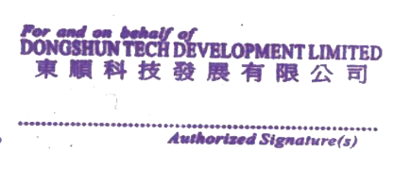
Provided and confirmed by :
Dongshun Tech Development Limited Jumping
----------------------------------------------------------------
Sales Manager

